4
Database Queries with SQL

Review and Preview

At this point in our study, we can view any table that is part of a database (a native table). A powerful feature of any database management system is to have the ability to form any view of the data we desire. The formation of such virtual tables is discussed in this chapter.

Virtual data views are obtained by querying the database. The language used for such queries is the structured query language, or SQL. In this chapter, we will learn how to use SQL to extract desired information from a database. Note SQL is not just used with Visual C# database applications. It is the standard language for database queries, hence all material learned here can be transferred to other database management systems.

SQL Background

SQL was developed at IBM in the early 1970’s, coincident with relational database theory developed by E. F. Codd. SQL succeeded a previous database language called Sequel - hence, SQL is the “sequel to Sequel.” Because of this, many programmers pronounce SQL as “sequel.” The correct pronunciation is “ess-que-ell,” that is, just say the letters.

SQL is a set of statements that tell a database engine (such as the ADO .NET engine with Visual C#) what information the user wants displayed. The engine then processes that set of statements, as it sees fit, to provide the information. SQL statements fall into two categories: data manipulation language (DML) and data definition language (DDL). DDL statements can be used to define tables, indexes, and database relations. DML statements are used to select, sort, summarize, and make computations on data. We will discuss primarily DML statements.

SQL has been adopted as an ANSI (American National Standards Institute) standard. This means there is an established set of SQL statements that every database management system recognizes. Yet, even with this standard, each manufacturer has added its own ‘dialect’ to the standard. In these notes, we will use Microsoft SQL. When a statement or function does not agree with the ANSI standard, this will be pointed out to the reader.

Basics of SQL

SQL can be used with any database management system, not just Visual C#. Hence, the syntax learned here will help any database programmer. SQL is a set of about 30 statements for database management tasks.

To query a database, we form a SQL statement. A statement is a string of SQL keywords and other information, such as database table and field names. This statement tells the database engine what information we want from the database. You do not have to tell the database engine how to get the information - it does all the hard work for you!

What can a SQL statement accomplish?

- Sort records
- Choose fields
- Choose records
- Cross reference tables
- Perform calculations
- Provide data for database reports
- Modify data

Even though we don’t even know what a SQL statement looks like yet, we need to set some rules on how to construct such statements. Then, we will look at how to use a SQL statement in a Visual C# application.

All SQL keywords in a SQL statement will be typed in upper case letters. Even though SQL is ‘case-insensitive,’ this is good programming practice and allows us (and others) to differentiate between keywords and other information in a SQL statement.

SQL uses the term row to refer to a database record and the term column to refer to database field. This will not come into play in this class, but you should be aware of this difference if you read other books about SQL.

String information embedded within a SQL statement can be enclosed in double-quotes (“) or single-quotes (‘). With Visual C#, you should only use single-quotes to enclose embedded strings. The reason for this is that the SQL statement is itself a string - so, in Visual C# code, SQL statements must be enclosed in double-quotes. We enclose embedded strings with single-quotes to avoid confusion.

SQL supports the use of wildcards in forming data views. Here, we use the Microsoft SQL wildcard character, an asterisk (*). Use of wildcards will be illustrated in many examples. ANSI Standard SQL implementations use the percent sign (%) as a wildcard.

If a table or field name has an embedded space, that name must be enclosed in brackets ([]). For example, if the table name is My Big Table, in a SQL statement you would use:

[My Big Table]

This notation is not allowed in some SQL implementations. But in implementations that don’t recognize brackets, embedded spaces in table and field names are not allowed, so it should never be a problem. A good rule of thumb is to avoid embedded spaces in table and field names if you can.

To refer to a particular field in a particular table in a SQL statement, use a dot notation:

TableName.FieldName

If either the table or field name has embedded spaces, it must be enclosed in brackets. Again, avoid embedded spaces if possible.

Now, we’re ready to start forming SQL statements and using them with Visual C# applications. One warning - SQL is a very powerful ally in obtaining and modifying data in a database. But, it can also be very destructive - a single SQL statement can wipe out an entire database! So, be careful and always provide safeguards against such potential destruction.

Where Does SQL Fit in Visual C#?

In Chapter 3, we used a single SQL statement to look at some fields from the Titles table of the books database. The SQL statement was used to form a command object (based on a connection object), which in turn was used by a data adapter object to form a data table. The data table is then available for viewing using data bound controls.

The code involved in processing a SQL statement is (assumes all objects have been properly declared):

Access Database:

myCommand = new OleDbCommand(mySQL, myConnection);
myAdapter.SelectCommand = myCommand;
myAdapter.Fill(myTable);

SQL Server Database:

myCommand = new SqlCommand(mySQL, myConnection);
myAdapter.SelectCommand = myCommand;
myAdapter.Fill(myTable);

In this code, mySQL is the SQL statement applied against a connection object myConnection (it is assumed that the connection object has been opened against a database). The resulting command object (myCommand) is used by the data adapter (myAdapter) to form the data table (myTable). This table is then used for data binding.

A result of interest from a SQL query is the number of records returned (if any). The data table formed has that information in the following property:

myTable.Rows.Count

Example 4-1

SQL Tester

Well, now we know some of the rules and syntax of SQL statements and how to use them with Visual C#, but we still don’t know what a SQL statement looks like (well, we saw a couple of examples in Chapter 3). We correct all that now and start learning more about SQL. To test SQL statements we form, we build this example which allows us to enter SQL statements and see the results of the formed database queries. The books database (BooksDB.accdb) is used in this example.

- Start a new project. Add a text box control, two label controls, a button, and a data grid view control to the form. Wait, you say, what is a DataGridView control? The DataGridView control allows us to view and edit an entire database table by setting just one property (DataSource). Resize and position the controls so your form looks something like this:

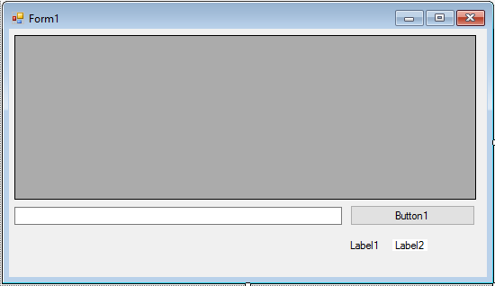
- Set properties for the form and controls:

Form1:
Name frmSQLTester
FormBorderStyle FixedSingle
StartPosition CenterScreen
Text SQL Tester

label1:
AutoSize False
Text Records Returned

label2:
Name lblRecords
AutoSize False
TextAlign MiddleCenter
BackColor White
BorderStyle FixedSingle
Text 0
FontSize 12

button1:
Name btnTest
Text Test SQL Statement
TabStop False

dataGridView1:
Name grdSQLTester
TabStop False

textBox1:
Name txtSQLTester
MultiLine True
ScrollBars Vertical

When done, the form should look like this:

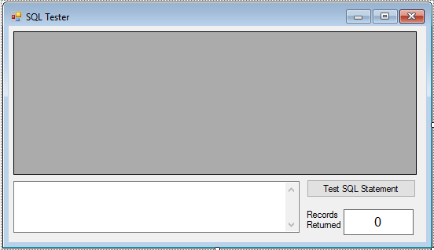

With this example, we will type SQL statements in the text box area, then click the Test SQL Statement button. The data grid will display the returned records, while the label control will display the number of records returned. We need some code to do all of this.

- Add this line at the top of the code window to allow use of data objects:

using System.Data.OleDb;

- Form level declaration for connection object:

OleDbConnection booksConnection;
- Code for the frmSQLTester Load method that opens the database:

private void FrmSQLTester_Load(object sender, EventArgs e)
{
// connect to books database
booksConnection = new OleDbConnection("Provider=Microsoft.ACE.OLEDB.12.0; Data Source = c:\\VCSDB\\Working\\BooksDB.accdb");
booksConnection.Open();
}

- Code for the frmSQLTester FormClosing method:

private void FrmSQLTester_FormClosing(object sender, FormClosingEventArgs e)
{
booksConnection.Close();
booksConnection.Dispose();
}

- Code for the btnTest Click method:

private void BtnTest_Click(object sender, EventArgs e)
{
OleDbCommand resultsCommand = null;
OleDbDataAdapter resultsAdapter = new OleDbDataAdapter();
DataTable resultsTable = new DataTable();
try
{
// establish command object and data adapter
resultsCommand = new OleDbCommand(txtSQLTester.Text, booksConnection);
resultsAdapter.SelectCommand = resultsCommand;
resultsAdapter.Fill(resultsTable);
// bind grid view to data table
grdSQLTester.DataSource = resultsTable;
lblRecords.Text = resultsTable.Rows.Count.ToString();
}
catch (Exception ex)
{
MessageBox.Show(ex.Message, "Error in Processing SQL", MessageBoxButtons.OK, MessageBoxIcon.Error);
}
resultsCommand.Dispose();
resultsAdapter.Dispose();
resultsTable.Dispose();
}

Let’s spend some time seeing what’s going on in this code. The first thing we do is use exception handling (the try block). Without it, if we make a small error in a SQL statement, the program will stop. With it, we get a message indicating our mistake and are allowed to continue. Following error control, the SQL statement (from txtSQLTester) is processed by the data adapter (resultsAdapter) and the data table (resultsTable) established. The number of records is then displayed.

Be careful in typing SQL statements. Although we have exception handling in SQL Tester, if you make a mistake, the returned error messages are (many times) not of much help. If you get an error, the best thing to do is retype the SQL command, paying attention to spacing, spelling, and proper punctuation.

- Save the application (saved in the Example 4-1 folder in VCSDB\Code\Class 4 folder) and run it. Type the only SQL statement you know at this time in the text box (SELECT * FROM Titles). Click Test SQL Statement and you should see (it may take several seconds for the records to appear):

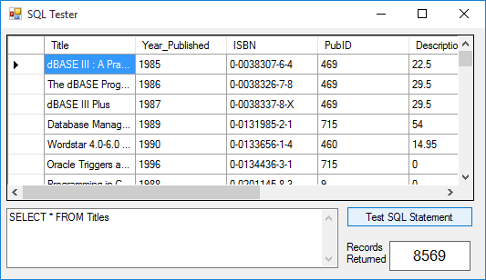

Note the data grid view control displays the entire table. You can scroll through the table or edit any values you choose. Any changes are automatically reflected in the underlying database. Column widths can be changed at run-time. Multiple row and column selections are possible. It’s a very powerful tool. Please note Records Returned values for your results may be different, depending on the current data in the database.

Change the word SELECT to SLECT to make sure the error trapping works. You should see:

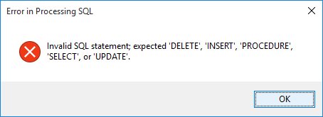

Now, let’s use this SQL Tester to examine many kinds of SQL statements. When typing the statements, use upper case letters for the SQL keywords. Statements do not necessarily have to be on a single line - multiple line SQL statements are fine and usually make them easier to read and understand.
Example 4-1

Using SQL Server Databases

Differences in the SQL Server version of the example:

- The SQL Server version of the books database is SQLBooksDB.mdf. Copy SQLBooksDB.mdf to your working directory

- Use this using statement:

using System.Data.SqlClient;

- In declarations, use this connection object:

SqlConnection booksConnection;

- In frmSQLTester Load method, use this connection object:

booksConnection = new SqlConnection("Data Source=.\\SQLEXPRESS; AttachDbFilename=c:\\VCSDB\\Working\\SQLBooksDB.mdf; Integrated Security=True; Connect Timeout=30; User Instance=True");

- In btnTest Click method:

Change all instances of OleDbCommand to SqlCommand
Change all instances of OleDbDataAdapter to SqlDataAdapter

The SQL Server version is saved in the Example 4-1 SQL folder in VCSDB\Code\Class 4 folder.
SELECT/FROM SQL Statement

The most commonly used SQL statement is the one we’ve been using as an example: the SELECT/FROM statement. This statement allows you to pick fields from one or more tables.

The syntax for a SELECT/FROM SQL statement is:

SELECT [Fields] FROM [Tables]

where [Fields] is a list of the fields desired and [Tables] is a list of the tables where the fields are to be found. The wildcard character (*) can be used for the fields list to select all fields from the listed table(s). For example, the statement we have been using:

SELECT * FROM Titles

selects and returns all fields from the books database Titles table. Look at all fields in the other tables (Authors, Publishers, Title_Author) using similar statements. Looking at each table will reacquaint you with the structure of the books database tables and fields. We will use a lot in the rest of this chapter.

If we only want selected fields from a table, we use a field list, which is a comma-delimited list of the fields desired, or:

SELECT Field1, Field2, Field3 FROM Table

will return three named fields from Table. Make sure you do not put a comma after the last field name. To obtain just the Title and Year_Published fields from the books database Titles table, use:

SELECT Title,Year_Published FROM Titles

Note the field names are not written using the prescribed dot notation of Table.Field. The table name omission is acceptable here because there is no confusion as to where the fields are coming from. When using multiple tables, we must use the dot notation.

Try this with the SQL tester and you will see just two fields are returned.

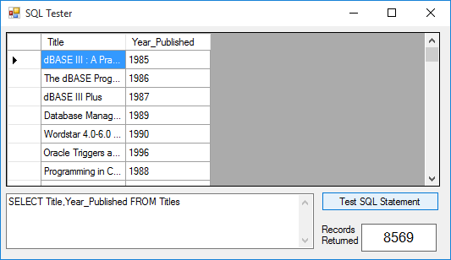

The DISTINCT keyword can be used with SELECT to restrict the returned records to one per unique entry for the field. That is, there are no duplicate entries. As an example, first try this with the SQL tester:

SELECT PubID FROM Titles

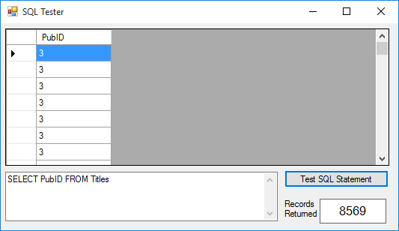

Now, try:

SELECT DISTINCT PubID FROM Titles

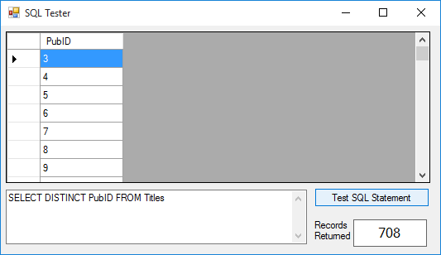

You should see far fewer records are returned - only distinct publishers are returned.

ORDER BY Clause

When you use a SELECT/FROM statement, the records are returned in the order they are found in the selected table(s). To sort the returned records in some other order, you use the ORDER BY clause. The syntax is:

SELECT [Fields] FROM [Tables] ORDER BY FieldSort

This statement selects the listed fields from the listed tables and sorts them by the field named FieldSort. By default, the ordering is in ascending order. If you want the sort to be in descending order, the FieldSort name is followed by the keyword DESC.

Try this statement with the SQL Tester:

SELECT * FROM Titles ORDER BY PubID

All records in the Titles table will be returned in order of Publisher ID.

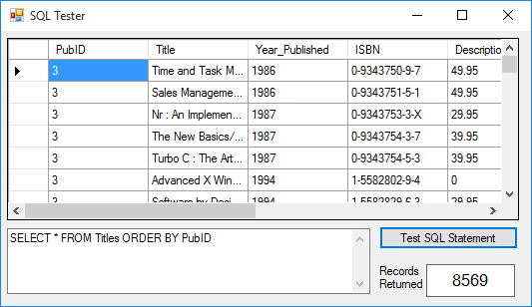

Try this and the order should be reversed:

SELECT * FROM Titles ORDER BY PubID DESC

You can use more than one field in the ORDER BY clause. SQL will create a data table based on all requested orderings. Try this with SQL tester:

SELECT * FROM Titles ORDER BY PubID,Title

The returned records will be in order of the publishers, with each publisher’s titles in alphabetic order.

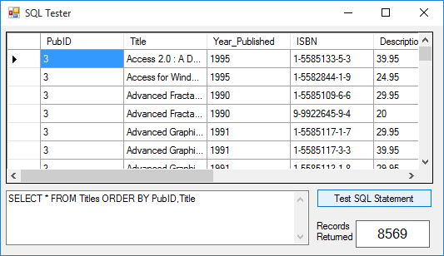

If you want to restrict the number of records returned by a SQL statement that orders the returned records, you can use the TOP keyword with SELECT. TOP n returns the first n records. TOP n PERCENT returns the first n percent of the returned records. If two or more records have the same order value, they are all returned. Use the SQL Tester and try:

SELECT TOP 20 * FROM Titles ORDER BY PubID,Title

Twenty books should be returned. Now, try:

SELECT TOP 20 PERCENT * FROM Titles ORDER BY PubID,Title

Far more books will be returned.

WHERE Clause

One of the most useful aspects of the SELECT/FROM SQL statement is its ability to limit the returned data table via the WHERE clause. This clause specifies some criteria that must be met in forming the data table. The syntax is:

SELECT [Fields] FROM [Tables] WHERE Criteria

The WHERE clause limits the number of returned records by allowing you to do logical checks on the value of any field(s). Operators used to perform these checks include:

< Less than <= Less than or equal to
> Greater than >= Greater than or equal to
= Equal <> Not equal

Other operators are:

Between Within a specified range
In Specify a list of values
Like Wild card matching

The WHERE clause can limit information displayed from one table or combine information from one or more tables. First, let’s do some single table examples using SQL Tester.

Single Table WHERE Clause

Say we want to see all fields in the books database Titles table for books published after 1995. And, we want the returned records ordered by Title. The SQL statement to do this is (we’ll type each clause on a separate line to clearly indicate what is going on - multiple line SQL statements are acceptable and, many times, desirable):

SELECT *
FROM Titles
WHERE Year_Published > 1995
ORDER BY Title

This is where the real power of SQL comes in. With this simple statement, the database engine quickly finds the desired records and sorts them - all without any coding on our part!

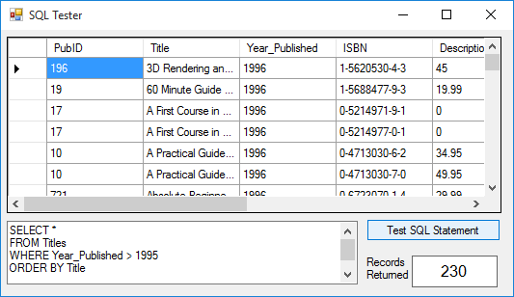

What if we want to know information about all the book publishers in the state of Washington. Try this SQL statement with the BooksDB.accdb Publishers table:

SELECT * FROM Publishers WHERE State = 'WA'

Note we enclosed the state name abbreviation (a string) in single quotes, as discussed earlier in this chapter. Try this SQL statement with the SQL tester and you should find one lonely publisher (BetaV) in the state of Washington!:

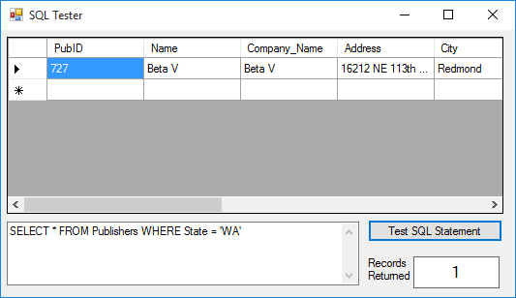

Wonder where Microsoft is?

The BETWEEN keyword allows us to search for a range of values. Want all books published between 1995 and 1998? Use this SQL statement:

SELECT * FROM Titles WHERE Year_Published
BETWEEN 1995 AND 1998

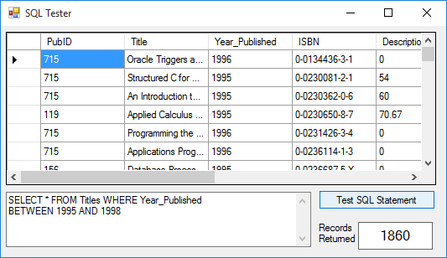

The IN keyword lets us specify a comma-delimited list of desired values in the returned data table. Say, we want to know the publishers in New York, Massachusetts, and California. This SQL statement will do the trick:

SELECT * FROM Publishers WHERE State IN ('NY', 'MA', 'CA')

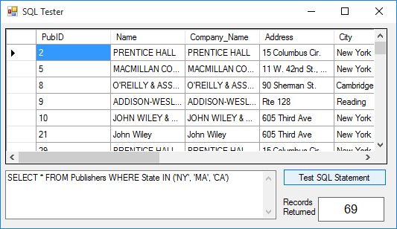

The LIKE keyword allows us to use wildcards in the WHERE clause. This lets us find similar fields. Recall, the Microsoft SQL wildcard character is the asterisk (*). For this example to work, you need to use % as a wildcard in the LIKE clause. The % is a SQL standard for wildcards. To find all authors with a ‘g’ anywhere in the their name, try:

SELECT * FROM Authors WHERE Author LIKE '%g%'

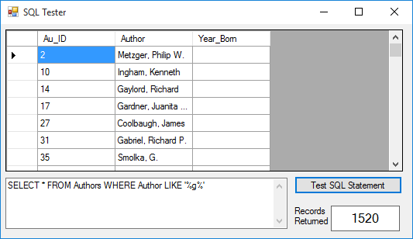

Multiple criteria are possible by using the logical operators AND and OR. For example, to find all books in the Titles table published after 1993 with a title that starts with the letters Data, we would use the SQL statement:

SELECT * FROM Titles
WHERE Year_Published > 1993 AND Title LIKE 'Data%'

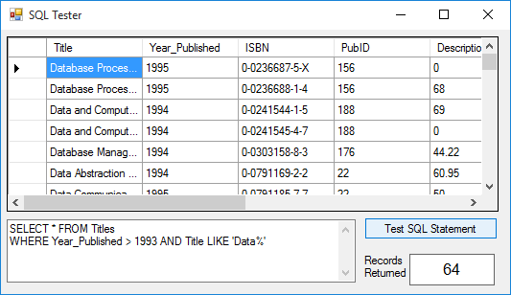
Multiple Table WHERE Clause

So far, almost everything we’ve done in this course has involved looking at a single native (built-in) table in a database. This has been valuable experience in helping us understand database design, learning how to use the Visual C# database tools, and learning some simple SQL statements. Now, we begin looking at one of the biggest uses of database management systems - combining information from multiple tables within a database. SQL makes such combinations a simple task.

We still use the same SELECT/FROM syntax, along with the WHERE and ORDER BY clauses to form our new virtual tables:

SELECT [Fields]
FROM [Tables]
WHERE Criteria
ORDER BY [Fields]

The only difference here is there’s more information in each SQL statement, resulting is some very long statements. The [Fields] list will have many fields, the [Tables] list will have multiple tables, and the Criteria will have several parts. The basic idea is to have the SQL statement specify what fields you want displayed (SELECT), what tables those fields are found in (FROM), how you want the tables to be combined (WHERE), and how you want them sorted (ORDER BY). Let’s try an example.

Notice the Titles table does not list a book’s publisher, but just publisher identification (PubID). What if we want to display a book’s title (Title field in Titles table) and publisher (Company_Name in Publishers table) in the same data table? Let’s build the SQL statement. First, the SELECT clause specifies the fields we want in our ‘virtual’ table:

SELECT Titles.Title,Publishers.Company_Name

Note the use of dot notation to specify the desired fields. With multiple tables, this avoids any problems with naming ambiguities.

The FROM clause names the tables holding these fields:

FROM Titles,Publishers

The WHERE clause declares what criteria must be met in combining the two tables. The usual selection is to match a primary key in one table with the corresponding foreign key in another table. Here, we want the publisher identification numbers from each table to match:

WHERE Titles.PubID = Publishers.PubID

Any records from the tables that do not match the WHERE criteria are not included in the returned data table.

Lastly, we declare how we want the resulting data table to be sorted:

ORDER BY Titles.Title

The complete SQL statement is thus:

SELECT Titles.Title,Publishers.Company_Name

FROM Titles,Publishers
WHERE Titles.PubID = Publishers.PubID
ORDER BY Titles.Title

Try this with the SQL tester.

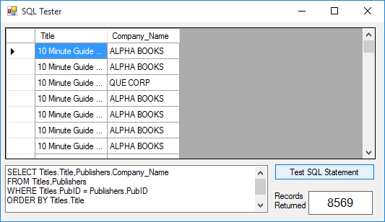

Are you amazed? You have just seen one of the real powers of using SQL with the ADO .NET database engine (or any database system, for that matter). We simply told the engine what we wanted (via the SQL statement) and it did all of the work for us - no coding needed! Let’s do some more examples.

In the previous example, say you just want books published by Que Corporation. Modify the SQL statement to read (we added an AND clause):

SELECT Titles.Title,Publishers.Company_Name
FROM Titles,Publishers
WHERE Titles.PubID = Publishers.PubID
AND Publishers.Company_Name = 'QUE CORP'
ORDER BY Titles.Title

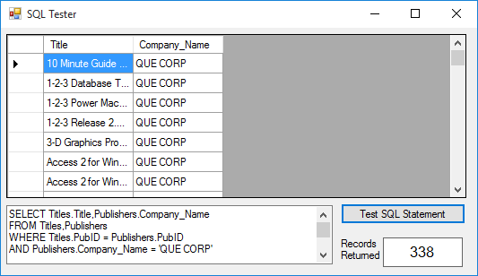

What if we want to list a book’s title, publisher, and author, ordered by the author names? This requires using all four tables in the books database. Let’s build the SQL statement. We want three fields:

SELECT Authors.Author,Titles.Title,Publishers.Company_Name

As mentioned, to retrieve this information requires all four tables:

FROM Authors,Titles,Publishers,Title_Author

We still need the publisher identification numbers to match, but now also need to make sure book titles (via the ISBN field) and author identification numbers match. The corresponding WHERE clause is:

WHERE Titles.ISBN = Title_Author.ISBN

AND Authors.Au_ID = Title_Author.Au_ID
AND Titles.PubID = Publishers.PubID

Finally, the results are sorted:

ORDER BY Authors.Author

Putting all this in the SQL tester gives us over 16,000 listings (one entry for every author and every book he or she wrote or co-wrote):

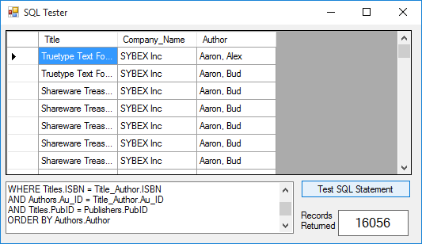
Such power! Can you imagine trying to write C# code to perform this record retrieval task?

If the displayed field name does not clearly describe the displayed information, you can alias the name, or change it to something more meaningful using the AS clause. As a simple example, try this:

SELECT Au_ID AS This_Author FROM Authors

Notice the displayed column is now This_Author.

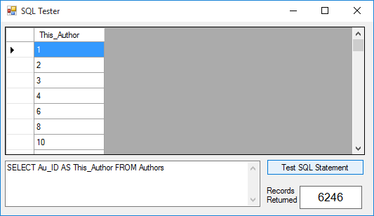

The field name is unaffected by aliasing - only the displayed name changes.

INNER JOIN Clause

When combining tables, the SQL INNER JOIN clause does the same work as the WHERE clause. The syntax for an INNER JOIN is a little different than that of the WHERE clause.

SELECT [Fields]
FROM Table1 INNER JOIN Table2 ON Linking Criteria
WHERE Criteria
ORDER BY [Fields]

This rather long statement begins by specifying the fields to SELECT. The FROM clause specifies the fields will come from the first table (Table1) being INNER JOINed with a second table (Table2). The ON clause states the linking criteria (usually a matching of key values) to be used in the join. At this point, the tables are combined. You can still use a WHERE clause to extract specific information from this table (you just can’t use it to combine tables) and an ORDER BY clause, if desired. Let’s repeat the examples just done with the WHERE clause.

To display a book title and publisher name, the SELECT clause is:

SELECT Titles.Title, Publishers.Company_Name

We want to ‘join’ the Titles table with the Publishers table, making sure the PubID fields match. The corresponding INNER JOIN statement is:

FROM Titles INNER JOIN Publishers
ON Titles.PubID = Publishers.PubID

Lastly, we order by the Title:

ORDER BY Titles.Title

Try this SQL statement in the SQL tester and you should obtain the same results seen earlier with the WHERE clause:

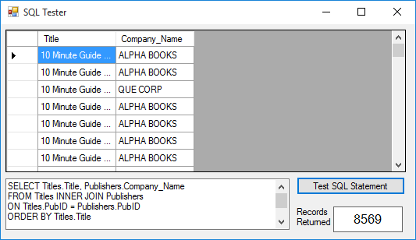

To illustrate use of the WHERE clause (to limit displayed records) in conjunction with the JOIN clause, try this modified SQL statement with SQL Tester:

SELECT Titles.Title, Publishers.Company_Name

FROM Titles INNER JOIN Publishers
ON Titles.PubID = Publishers.PubID
WHERE Publishers.Company_Name = 'QUE CORP'
ORDER BY Titles.Title

Only QUE CORP publishers will be listed.
Use of the INNER JOIN clause to combine information from more than two tables is a little more complicated. The tables need be joined in stages, nesting the INNER JOIN clauses using parentheses for grouping. Assume we have three tables (Table1, Table2, Table3) we want to combine. Table1 and Table3 have a common key field for linking (Key13), as do Table2 and Table3 (Key23). Let’s combine these three tables using INNER JOIN. In the first stage, we form a temporary table that is a result of joining Table2 and Table3 using Key23 for linking:

Table2 INNER JOIN Table3 ON Table2.Key23 = Table3.Key23

In the next stage, we join Table1 with this temporary table (enclose it in parentheses) using Key13 for linking:

Table1 INNER JOIN
(Table2 INNER JOIN Table3 ON Table2.Key23 = Table3.Key23)
ON Table1.Key13 = Table3.Key13

This nested statement is used in the SQL statement to specify the tables for field selection. Notice we’ve spread this over a few lines to make it clearer - any SQL processor can handle multiple line statements. The multiple table INNER JOIN can be generalized to more tables - just pay attention to what tables link with each other. Always make sure the tables you are joining, whether a temporary joined table or a database table, have a common key.

Remember the example we did earlier where we listed Author, Title, and Publisher in the books database? Let’s build that SQL statement. First, SELECT the fields:

SELECT Authors.Author,Titles.Title,Publishers.Company_Name

This is the same SELECT we used previously. Now, we need to form the FROM clause by combining four tables in three stages (one for each common key linking). In the first stage, combine the Publishers and Titles tables (PubID is common key):

FROM Publishers INNER JOIN Titles
ON Publishers.PubID=Titles.PubID

Now, join this temporary table (put its statement in parentheses) with the Title_Author table (ISBN is common key):

FROM (Publishers INNER JOIN Titles
ON Publishers.PubID=Titles.PubID)
INNER JOIN Title_Author
ON Titles.ISBN=Title_Author.ISBN

In the final stage, join the Authors table with this temporary table (enclose its statement in parentheses) using Au_ID as the key:

FROM Authors INNER JOIN
((Publishers INNER JOIN Titles
ON Publishers.PubID=Titles.PubID)
INNER JOIN Title_Author
ON Titles.ISBN=Title_Author.ISBN)
ON Authors.Au_ID=Title_Author.Au_ID

The FROM clause needed for the combined data view is now complete. The final line in the SQL statement orders the data:

ORDER BY Authors.Author

Whew! Try this full statement with the SQL tester and you should get the same results seen earlier using the WHERE clause.

OUTER JOIN Clause

The INNER JOIN only retrieves records that have a match on both sides of the JOIN. For example, with the books database, look at this INNER JOIN statement:

Publishers INNER JOIN Titles ON Publishers.PubID = Titles.PubID

In this statement, if there is a PubID in the Publishers table without a corresponding PubID in the Titles table, that value will not be in the returned data table. If you want all records returned, whether there is a match or not, you need to use what is called an OUTER JOIN. There are two forms for the OUTER JOIN.

A RIGHT OUTER JOIN includes all records from the second-named table (the right-most table), even if there are no matching values for records in the first-named (left-most table). Try this with SQL Tester:

SELECT Titles.Title, Publishers.Company_Name
FROM Titles

RIGHT OUTER JOIN Publishers
ON Titles.PubID = Publishers.PubID
ORDER BY Titles.Title

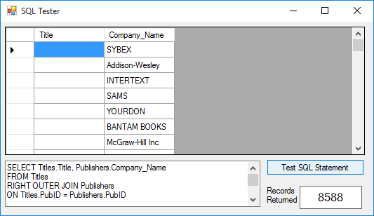

There are several publishers (about 19 or so) without corresponding titles in the database.
A LEFT OUTER JOIN includes all records from the first-named table (the left-most table), even if there are not matching values for records in the second-named (right-most table). Try this with SQL Tester:

SELECT Titles.Title, Publishers.Company_Name
FROM Titles
LEFT OUTER JOIN Publishers
ON Titles.PubID = Publishers.PubID
ORDER BY Titles.Title

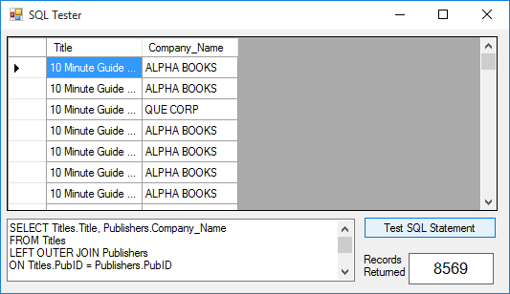

The returned data table is identical to that obtained with the INNER JOIN. Obviously, all books in the database have a corresponding publisher - that’s actually a good thing.

Functions with SQL (Access Database)

SQL offers some basic functions that let you modify the displayed information. It does not affect the underlying information in the database. As an example, say you want all book titles in the books database Titles table to be listed in upper case letters. Try this SQL statement with SQL Tester:

SELECT UCase(Titles.Title) FROM Titles ORDER BY Titles.Title

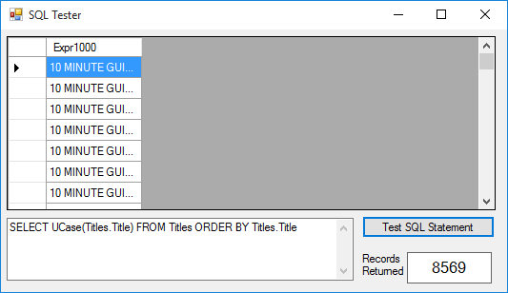

Notice SQL assigns a heading of Expr1000 to this ‘derived’ field. We can use the alias feature of SQL change this heading to anything we want (except the name of an existing field). Try this:

SELECT UCase(Titles.Title) AS Title FROM Titles

Or, what if we had some process that could only use the 10 left-most characters of the book title. This SQL statement will do the trick:

SELECT Left(UCase(Titles.Title), 10) AS Title FROM Titles

You can also do BASIC math in a SQL statement. The BOOKS database Authors table has Year_Born as a field. This SQL statement will display each author and their age in 2006 (when this is being written):

SELECT Authors.Author,(2006-Authors.Year_Born) AS Age
FROM Authors

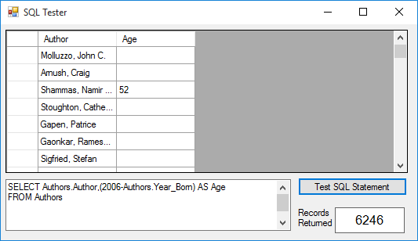

Note that most of the listings do not have an Age value – I had to scroll down a bit to find one. The reason for this is because only a few of the author records have birth year entries - the entries are NULL (containing no information).

NULL is a special value meaning there is nothing there - this is not the same as an empty string or blank space. In our work, we will try to avoid placing NULLs in a database, but sometimes this is not possible or they may exist in other databases. You need to decide how to handle NULLs in your design. We will see examples where they cause problems. A NULL field can be tested using the SQL functions IS NULL and IS NOT NULL. We can add this to the SQL statement above to find just the Authors records with a birth year:

SELECT Authors.Author,(2006-Authors.Year_Born) AS Age
FROM Authors
WHERE Authors.Year_Born IS NOT NULL

You should now find 20 authors with ages listed.
Functions with SQL (SQL Server Database)

There are functions available for use as part of a SQL statement with SQL Server databases (consult SQL Server references for a full list of such functions). This lets you modify the displayed information. It does not affect the underlying information in the database. As an example, say you want all book titles in the SQLBooksDB.mdf database Titles table to be listed in upper case letters. Try this SQL statement with SQL Tester:

SELECT UPPER(Titles.Title) FROM Titles ORDER BY Titles.Title

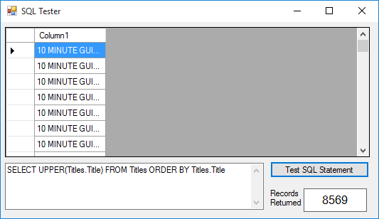

Notice SQL assigns a heading of Column1 to this ‘derived’ field. We can use the alias feature of SQL change this heading to anything we want (except the name of an existing field). Try this:

SELECT UPPER(Titles.Title) AS Title FROM Titles

Or, what if we had some process that could only use the 10 left-most characters of the book title. This SQL statement will do the trick:

SELECT LEFT(UPPER(Titles.Title), 10) AS Title FROM Titles

You can also do BASIC math in a SQL statement. The BOOKS database Authors table has Year_Born as a field. This SQL statement will display each author and their age in 2006 (when this is being written):

SELECT Authors.Author,(2006-Authors.Year_Born) AS Age
FROM Authors

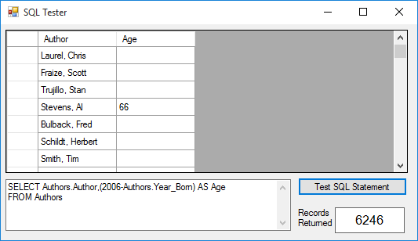

Note that most of the listings do not have an Age value – I had to scroll down a bit to find one. The reason for this is because only a few of the author records have birth year entries - the entries are NULL (containing no information).

NULL is a special value meaning there is nothing there - this is not the same as an empty string or blank space. In our work, we will try to avoid placing NULLs in a database, but sometimes this is not possible or they may exist in other databases. You need to decide how to handle NULLs in your design. We will see examples where they cause problems. A NULL field can be tested using the SQL functions IS NULL and IS NOT NULL. We can add this to the SQL statement above to find just the Authors records with a birth year:

SELECT Authors.Author,(2006-Authors.Year_Born) AS Age
FROM Authors
WHERE Authors.Year_Born IS NOT NULL

You should now find 20 authors with ages listed.

SQL Aggregate Functions

In addition to SQL functions, the ADO .NET database engine supports the standard SQL aggregate functions. These are functions that let you compute summary statistics for fields in your database, alias the results, and display them in a data table. NULL fields are ignored by the aggregate functions.

The aggregate functions and their results are:

AVG(Field) Average value of the field
COUNT(Field) Number of entries for the field
FIRST(Field) First value of the field
LAST(Field) Last value of the field
MAX(Field) Maximum value of the field
MIN(Field) Minimum value of the field
SUM(Field) Sum of the field values

Try this example with the Authors table:

SELECT
COUNT(Authors.Author) AS HowMany,
AVG(Authors.Year_Born) AS AveYear,
FIRST(Authors.Year_Born) AS FirstYear,
LAST(Authors.Year_Born) AS LastYear,
MAX(Authors.Year_Born) AS MaxYear,
MIN(Authors.Year_Born) AS MinYear,
SUM(Authors.Year_Born) AS SumYear
FROM Authors

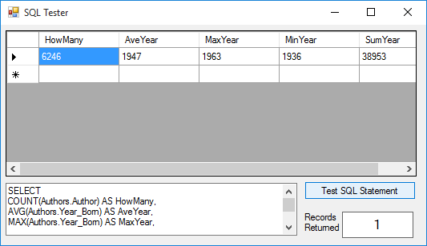

Note some of the aggregate fields (FIrstYear, LastYear) have no values since these are NULL fields.

Aggregate functions can be used to group results. The GROUP BY clause lets you determine records with duplicate field values. Want to know how many publishers in your database are in each state? Try this SQL statement:

SELECT Publishers.State, Count(Publishers.State) as HowMany
FROM Publishers
GROUP BY Publishers.State

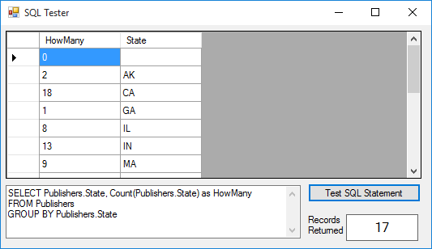

You can use the HAVING qualifier to further reduce the grouping obtained with a GROUP BY clause. Say in the above example, you only want to display states starting with the letter M (a strange request, we know). This SQL statement will do the trick:

SELECT Publishers.State, Count(Publishers.State) as HowMany
FROM Publishers
GROUP BY Publishers.State
HAVING Publishers.State LIKE 'M%'

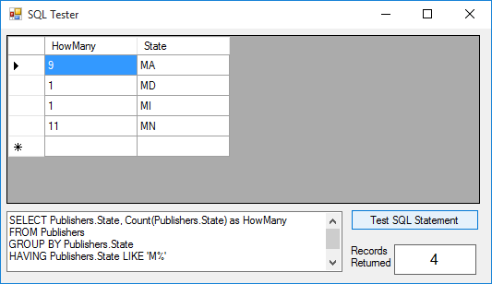
SQL Construction Tools

We’ve completed our review of the SQL language. There are other commands we haven’t looked at. If you would like to know more, there are numerous references available for both ANSI standard SQL and the Microsoft version. You now know how to construct SQL statements to extract desired information from a multi-table database and you know how to read other’s SQL statements.

You have seen that constructing SQL statements is, at times, a tedious process. To aid in the construction of such statements, there are several tools available for our use. We’ll discuss two: one in Microsoft Access and one available with the data wizard (discussed in Chapter 3).

SQL Statements with Access

To build a SQL query using Microsoft Access, you obviously must have Access installed on your computer. As an example, we will build the SQL query that displays Author, Title, and Publisher for each book in the books database:

- Start Access and open your copy of the BooksDB.accdb. Click the Queries tab and select Create Query in Design View, click Open.
- In the Show Table form, add all four tables. When done, click Close. A split window appears with the four linked tables at the top (showing the relationships between primary and foreign keys) and a table in the lower portion.
- In the lower portion of the window, click the first Field column, click the drop-down arrow and select Authors.Author. Under Sort, choose Ascending (sorting by Author). In the second column, click the drop-down arrow and select Titles.Title. In the third column, click the drop-down arrow and select Publishers.Company_Name. When done, you should see (I moved the tables around a bit):

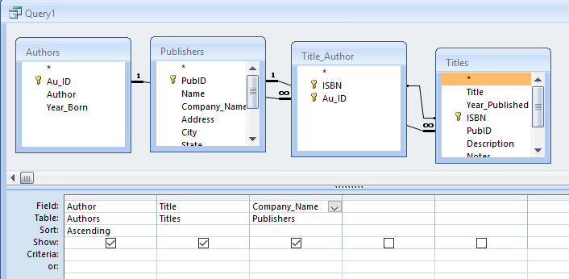

- Click the exclamation point (!) on the Access toolbar to build the data table. Now, click View on the main Access menu and select SQL View.
- Like magic, the SQL statement that was used to develop the data table is displayed:

SELECT Authors.Author, Titles.Title, Publishers.Company_Name
FROM (Publishers INNER JOIN Titles ON Publishers.PubID = Titles.PubID) INNER JOIN (Authors INNER JOIN Title_Author ON Authors.Au_ID = Title_Author.Au_ID) ON Titles.ISBN = Title_Author.ISBN
ORDER BY Authors.Author;

Notice a couple of things about this query. First, it uses the INNER JOIN clause to combine tables. Second, notice the semicolon (;) at the end of the query. This is not needed and will be ignored by the ADO .NET database engine. You could now cut and paste the above query wherever you need it in your Visual C# application. You may need to make some adjustments to the query to make sure it does not result in any syntax errors at run-time. Notice this generated query is very much like that developed earlier in these notes. It’s similar because the author used Access to generate that query - you, too, should use the Access query building capabilities whenever you can. You are assured of a correct SQL statement, helping to minimize your programming headaches.

SQL Statements with the Data Wizard

In Chapter 3, we looked at the Visual C# data wizard as a tool for building applications. Even though we won’t be using the wizard to build applications (primarily to simplify distribution of our applications), it can be used to generate any SQL statements we might need.

The steps here are similar to those just used with Access (not unexpected since they probably use the same underlying code). And, even though this example uses BooksDB.accdb, it can also be done with the SQL Server version (SQLBooksDB.mdf).

- Start a new project in Visual C#.

- Choose the Project menu item, then Add New Data Source. Click Next on the screens until you see (we assume the connection still ‘points’ to the books database; if not, do the steps necessary):

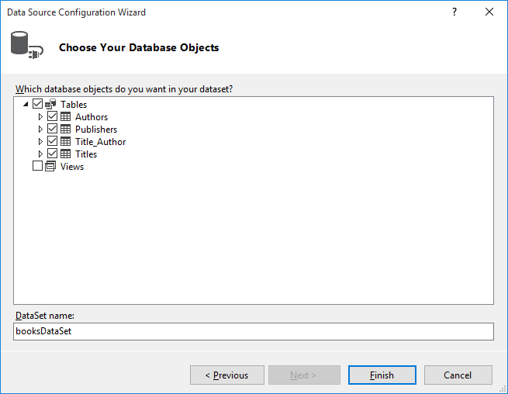

We need all tables in our dataset. Check Authors, Publishers, Title_Author and Titles. Then, click Finish.
A new dataset (booksDataSet) will appear in the Data Sources window:

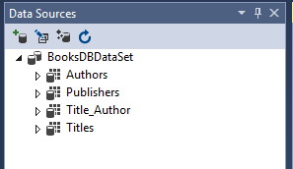

- We now need to add a table adapter to generate the needed fields from the tables to form another table. Highlight the booksDataSet in the Data Sources window and click the Edit DataSet with Designer button in the toolbar in that window. This window, displaying the four individual tables, will appear:

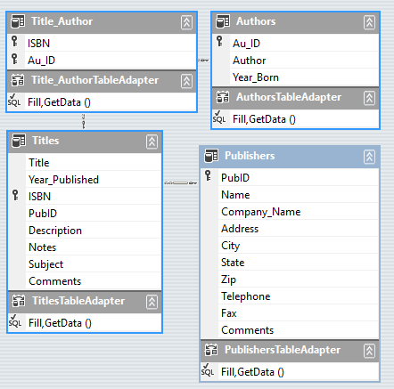

Our virtual table will include the Author, Title, and Company_Name fields. To build this table, we need a new TableAdapter. Right-click the display window, and choose Add, then TableAdapter.
- A new adapter will be added and the TableAdapter Configuration Wizard will start up. Click Next on the Choose Your Data Connection window and the subsequent Choose a Command Type Window (where we tell the adapter we are using SQL). The Enter a SQL Statement window will appear:

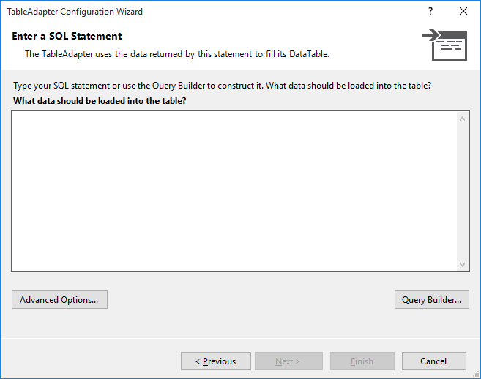

Here’s where we let the wizard build the SQL statement.
- Click Query Builder to see:

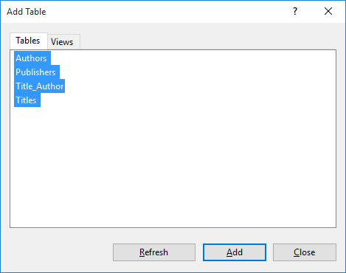

Select the Authors, Publishers, Title_Author and Titles tables and click Add.
- Click Close. You will see:

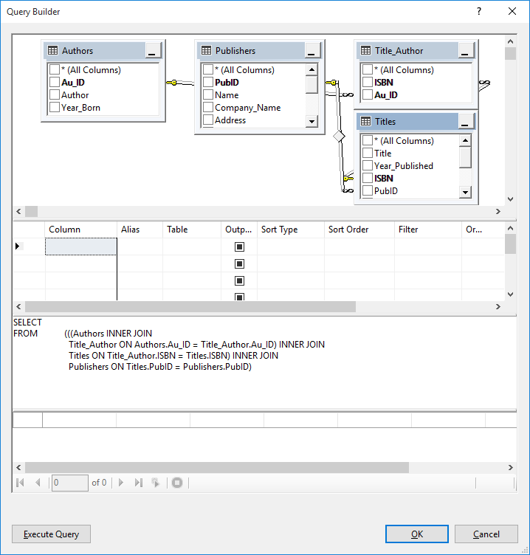

The Query Builder is showing the relationships among the tables (i.e. how the ISBN value connects Titles with Title_Author and how Au_ID connects Title_Author with Authors, how PubID connects Titles with Publishers). Select Title in the Titles table. Select Company_Name in the Publishers table. Then, select Author in the Authors table. Once added, select a sort type of Ascending in the table below. This will sort the table according to Author name.
- Once your selections are complete the window will appear as:

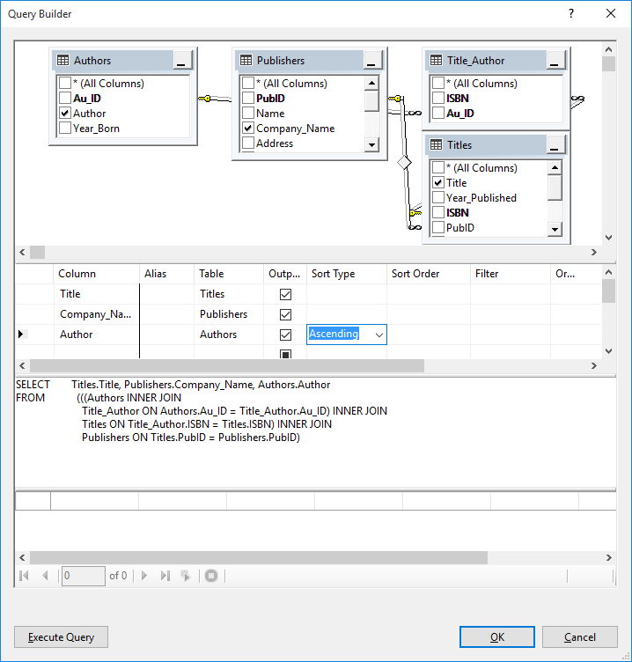

Click OK to see the following SQL statement is generated:

SELECT Titles.Title, Publishers.Company_Name, Authors.Author
FROM (((Authors INNER JOIN
Title_Author ON Authors.Au_ID = Title_Author.Au_ID) INNER JOIN
Titles ON Title_Author.ISBN = Titles.ISBN) INNER JOIN
Publishers ON Titles.PubID = Publishers.PubID)
ORDER BY Authors.Author

This is essentially the same SQL statement generated using Access (except there is no semicolon at the end). More steps were required. If you have Access, it’s probably the best way to generate SQL statements.
Building SQL Commands in Code

In each example in this chapter, we formed a SQL command and processed it to obtain a returned data table (our virtual data view). What do you do if you don’t know the SQL command prior to implementing it as a Visual C# property? For example, the user of the books database may want to know all the publishers in Chicago. Or, the user may want to search the database for all authors whose name starts with a G.

In both of the above examples, we have no idea what the user will select. We need to provide the user a method to make a selection then, once the selection is made, build the SQL statement in Visual C#. Fortunately, the C# language (used in all methods) is rich with string handling functions and building such statements in code is a relatively straightforward process.

To build a SQL command in code, form all the known clauses as string variables. Once the user makes the selections forming the unknown information, using the string concatenation operator (+) to place these selections in their proper position in the complete SQL statement. That statement can then be processed at run-time, using one of the methods discussed earlier in this chapter. The next example demonstrates this technique.

Example 4-2

Searching the Books Database

We build an application (using the BooksDB.accdb books database) that displays a book’s author, title, and publisher. The user may display all books in the database or, alternately, search the database for books by particular authors (searching by the first letter of the last name, using buttons for selection). There is a lot to learn in this example. You’ll see how to form a SQL command in code, how to get that statement into code, how to set up convenient search mechanisms, and how to build a nice interface, all topics covered in detail in Chapter 5.

- Start a new project. Add a data view grid control and one button. Position and resize the controls until the form looks something like this:

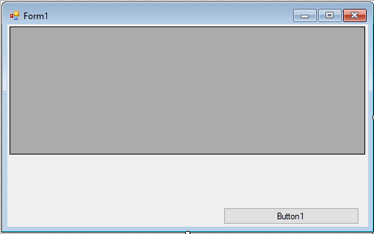

Make sure to leave space between the data grid and the button. We will use this space for two rows of button controls needed to search the database table.
- Set properties for the form and controls:

Form1:
Name frmBooks
FormBorderStyle FixedSingle
StartPosition CenterScreen
Text Books Database

button1:
Name btnAll
Text Show All Records

dataViewGrid1:
Name grdBooks
AutoSizeColumnsMode Fill

At this point, the form should appear similar to this:

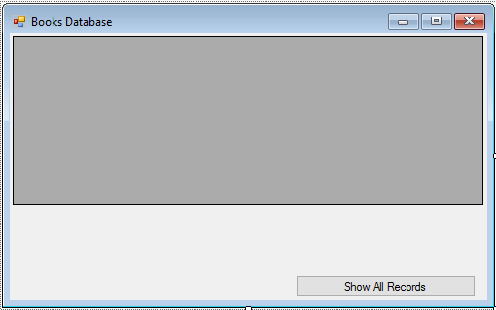

- Add this line at the top of the code window to allow use of data objects:

using System.Data.OleDb;

- Form level declarations:

OleDbConnection booksConnection;
String SQLAll;
Button[] btnRolodex = new Button[26];

SQLAll will be the variable that holds the default SQL statement. btnRolodex is an array of buttons used for searching.

- Code for the frmBooks Load method:

private void FrmBooks_Load(object sender, EventArgs e)
{
// connect to books database
booksConnection = new OleDbConnection("Provider=Microsoft.ACE.OLEDB.12.0; Data Source = c:\\VCSDB\\Working\\BooksDb.accdb");
booksConnection.Open();
// create Rolodex buttons for searching
int w, lStart, l, t;
int buttonHeight = 33; // found by trial and error
// search buttons
// determine button width - 13 on a row
w = Convert.ToInt32(this.ClientSize.Width / 14);
// center buttons on form
lStart = Convert.ToInt32(0.5 * (this.ClientSize.Width - 13 * w));
l = lStart;
t = grdBooks.Top + grdBooks.Height + 2;
// create and position 26 buttons
for (int i = 0; i < 26; i++)
{
// create new pushbutton
btnRolodex[i] = new Button();
btnRolodex[i].TabStop = false;
// set text property
btnRolodex[i].Text = ((char) (65 + i)).ToString();
// position
btnRolodex[i].Width = w;
btnRolodex[i].Height = buttonHeight;
btnRolodex[i].Left = l;
btnRolodex[i].Top = t;
// give cool colors
btnRolodex[i].BackColor = Color.Blue;
btnRolodex[i].ForeColor = Color.White;
// add button to form
this.Controls.Add(btnRolodex[i]);
// add event handler
btnRolodex[i].Click += new System.EventHandler(this.BtnSQL_Click);
// next left
l += w;
if (i == 12)
{
// move to next row
l = lStart;
t += buttonHeight;
}
}
// Build basic SQL statement
SQLAll = "SELECT Authors.Author,Titles.Title,Publishers.Company_Name ";
SQLAll += "FROM Authors, Titles, Publishers, Title_Author ";
SQLAll += "WHERE Titles.ISBN = Title_Author.ISBN ";
SQLAll += "AND Authors.Au_ID = Title_Author.Au_ID ";
SQLAll += "AND Titles.PubID = Publishers.PubID ";
// show form and click on all records initially
this.Show();
btnAll.PerformClick();
}

This routine creates the connection object and establishes the search buttons A through Z using the btnRolodex array. It determines button width and places them accordingly. Study the code that does this - it’s very useful. This routine also builds the default SQL statement that gets the Author, Title, and Publisher from the database. Note the statement is built in several stages, each stage appending another clause to the statement. Note, particularly, each subsequent clause has a space at the end to make sure there are no ‘run-ons’ of keywords. Lastly, all records are displayed by ‘clicking’ on the btnAll control.

- Code for the frmBooks FormClosing method:

private void FrmBooks_FormClosing(object sender, FormClosingEventArgs e)
{
booksConnection.Close();
booksConnection.Dispose();
}

- Code for the btnSQL Click method (handles the Click event for all control buttons):

private void BtnSQL_Click(object sender, EventArgs e)
{
OleDbCommand resultsCommand = null;
OleDbDataAdapter resultsAdapter = new OleDbDataAdapter();
DataTable resultsTable = new DataTable();
String SQLStatement;
// determine which button was clicked and form SQL statement
Button buttonClicked = (Button) sender;
switch (buttonClicked.Text)
{
case "Show All Records":
SQLStatement = SQLAll;
break;
case "Z":
// Z Clicked
// Append to SQLAll to limit records to Z Authors
SQLStatement = SQLAll + "AND Authors.Author > 'Z' ";
break;
default:
// Letter key other than Z clicked
// Append to SQLAll to limit records to letter clicked
int index = (int) (Convert.ToChar(buttonClicked.Text)) - 65;
SQLStatement = SQLAll + "AND Authors.Author > '" + btnRolodex[index].Text + " ' ";
SQLStatement += "AND Authors.Author < '" + btnRolodex[index + 1].Text + " ' ";
break;
}
SQLStatement += "ORDER BY Authors.Author";
// apply SQL statement
try
{
// establish command object and data adapter
resultsCommand = new OleDbCommand(SQLStatement, booksConnection);
resultsAdapter.SelectCommand = resultsCommand;
resultsAdapter.Fill(resultsTable);
// bind grid view to data table
grdBooks.DataSource = resultsTable;
}
catch (Exception ex)
{
MessageBox.Show(ex.Message, "Error in Processing SQL", MessageBoxButtons.OK, MessageBoxIcon.Error);
}
resultsCommand.Dispose();
resultsAdapter.Dispose();
resultsTable.Dispose();
}

This routine determines which button was clicked and forms the SQL statement. If the ‘Show All Records’ button is clicked, all records are displayed. If a letter button is clicked, it determines which letter was clicked by the user and appends an additional test (using AND) to the WHERE clause in the default SQL statement. This test limits the returned records to author’s names between the clicked letter and the next letter in the alphabet. Note that clicking Z is a special case. Once the SQL statement is formed, it is processed by the data adapter to form the data table.

- Save the application (saved in the Example 4-2 folder in VCSDB\Code\Class 4 folder). Run it. You should see:

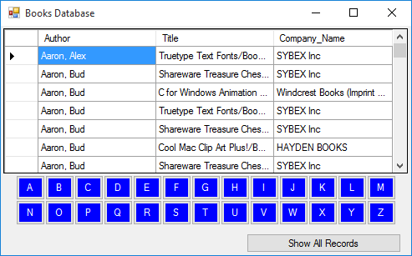

Notice how the search buttons are built and nicely displayed. Notice, too, that all records are displayed. Click one of the search buttons. Only records with author names matching the clicked letter will be displayed. Here’s what I see when I click the ‘G’ button:

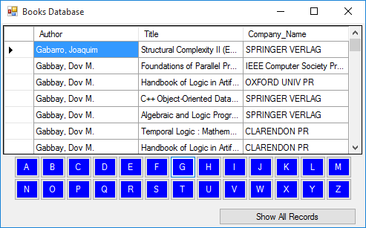
Example 4-2

Using SQL Server Databases

Differences in the SQL Server version of the example:

- The SQL Server version of the books database is SQLBooksDB.mdf. Copy SQLBooksDB.mdf to your working directory

- Use this using statement:

using System.Data.SqlClient;

- In declarations, use this connection object:

SqlConnection booksConnection;

- In frmSQLTester Load method, use this connection object:

booksConnection = new SqlConnection("Data Source=.\\SQLEXPRESS; AttachDbFilename=c:\\VCSDB\\Working\\SQLBooksDB.mdf; Integrated Security=True; Connect Timeout=30; User Instance=True");

- In btnSQL Click method:

Change all instances of OleDbCommand to SqlCommand
Change all instances of OleDbDataAdapter to SqlDataAdapter

The SQL Server version is saved in the Example 4-2 SQL folder in VCSDB\Code\Class 4 folder.
Summary

We’re now done with our long journey into the world of SQL. This has been a relatively complete overview and you will learn more as you become a more proficient database programmer. SQL is at the heart of obtaining a virtual view of desired database information.

Forming this virtual view using SQL was seen to be a straightforward, and sometimes complicated, process. Tools such as the Access SQL Builder and the SQL Build function of the Visual C# data wizard can help us build error free SQL queries. Even with such tools, it is important to know SQL so you can understand and modify SQL statements built and implemented by others.

SQL also has the ability to modify information in a database. You can also use SQL to add records, delete records, and even create new database tables. But, such capabilities are beyond this course. Besides, the same abilities are available to us using Visual C#. That is the approach we will use for actual database management tasks. Such tasks are covered in Chapter 6, following a discussion of building a proper Visual C# interface in Chapter 5.

Example 4-3

Northwind Traders Database

This example gives you more practice with SQL by looking at another database - the Northwind Traders database (NWindDB.accdb) studied in other chapters. This is an “open” exercise where you can do what you want until you feel you are more proficient in understanding SQL.

- First, modify the SQL Tester in Example 4-1 so it uses NWindDB.accdb (simply change the ConnectionObject):

NWindConnection = new OleDbConnection("Provider=Microsoft.ACE.OLEDB.12.0; Data Source = c:\\VCSDB\\Working\\NWindDB.accdb");

The connection object has been renamed for this example.

- Save (saved in the Example 4-3 folder in VCSDB\Code\Class 4 folder) and run your application. Now, try things. Use SQL to examine each of the eight tables (Categories, Customers, Employees, Order Details, Orders, Products, Shippers, Suppliers). Examine each field. Try selecting specific fields from tables. Try ordering the results. Try combining tables to show various information. Try the SQL aggregate functions to do some math. Use Access’s or the data wizard’s ability to generate SQL statements. Cut and paste those statements into SQL Tester to try them.

Here’s the result from finding all fields in the Customers table:

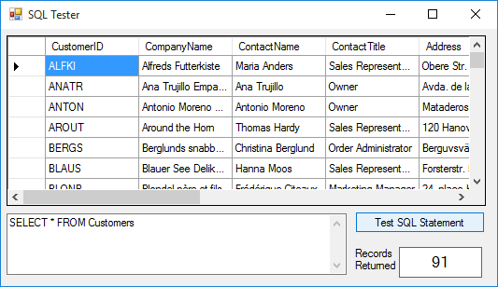

and here’s the same from the Products table:

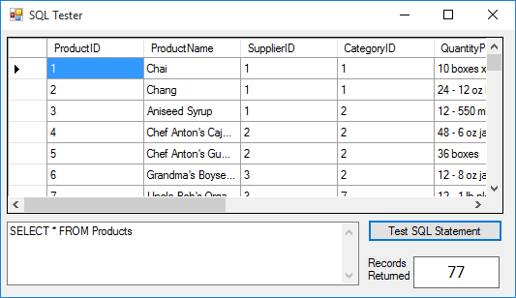
Example 4-3

Using SQL Server Databases

Modify the SQL Server version of Example 4-1 as follows:

The SQL Server version of the database is SQLNWindDB.mdf. Make sure SQLNWindDB.mdf is in your working directory

- Use this using statement:

using System.Data.SqlClient;

- In declarations, use this connection object:

SqlConnection NWindConnection;

- In frmSQLTester Load method, use this connection object:

NWindConnection = new SqlConnection("Data Source=.\\SQLEXPRESS; AttachDbFilename=c:\\VCSDB\\Working\\SQLNWindDB.mdf; Integrated Security=True; Connect Timeout=30; User Instance=True");

- In btnTest Click method:

Change all instances of OleDbCommand to SqlCommand
Change all instances of OleDbDataAdapter to SqlDataAdapter

The SQL Server version is saved in the Example 4-3 SQL folder in VCSDB\Code\Class 4 folder.

